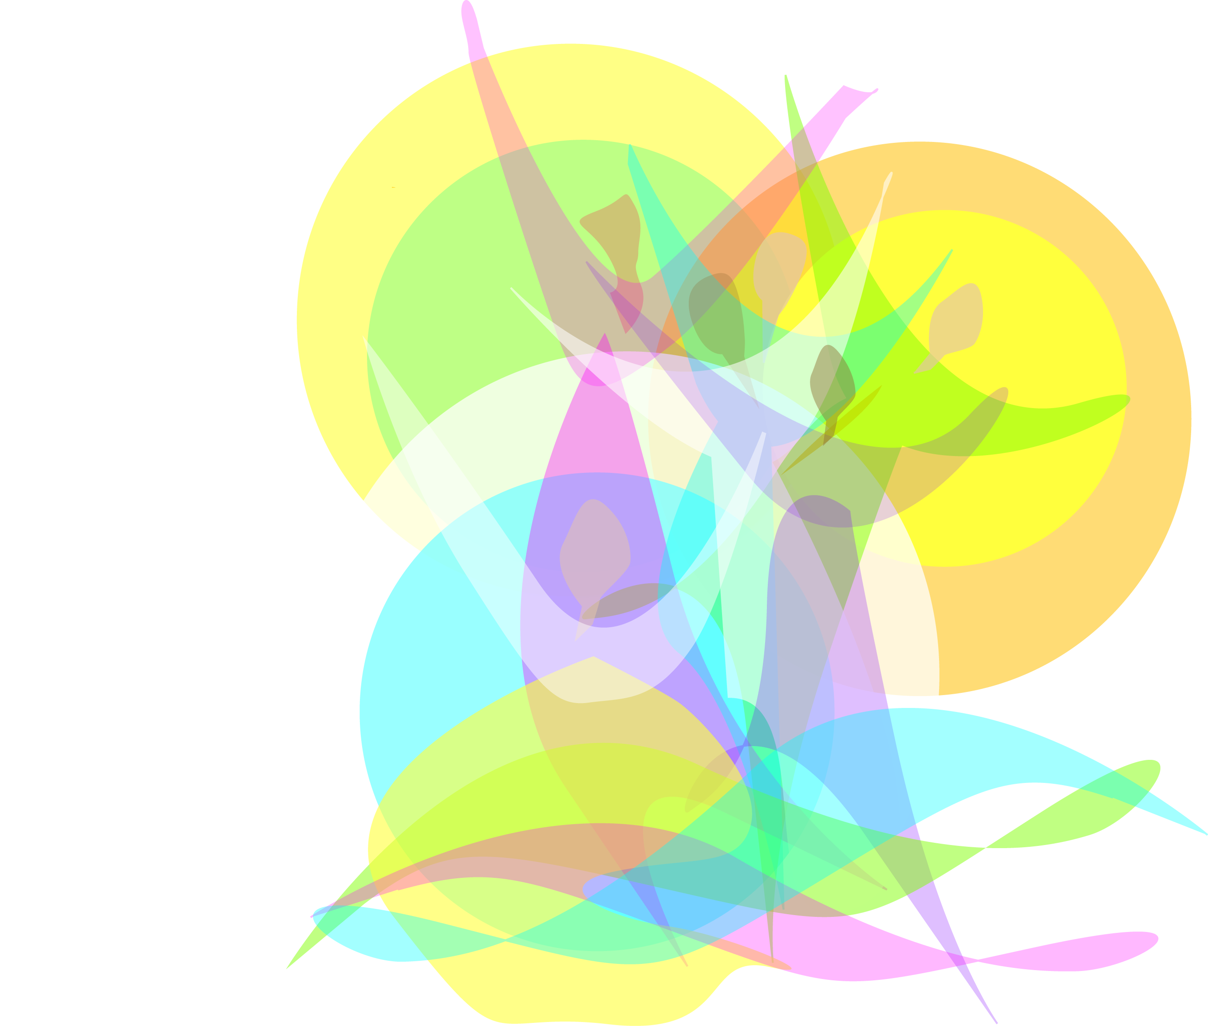
Morning Prayer: I Am Making Something New

Opening Together): Behold, I am making something new!

Today we gather.
Meeting together to consider
where we stand
and who we are.

Be with us, O God,
in this space and time
as we affirm and shape the changes
in our understanding of the Way.

We desire not to fly apart
in garish fantasy of vision
but rather to move the boundaries
that we have set before
in order to encompass and embrace
the living and breathing growth of each and all.

We work in prayer and dialogue.
In going back we see where we have been,
we steady ourselves
for the journey forward today.

Response: Behold! Behold! I am making something new!

Reader 1: Creative dreams are true and yours is very important.
Our dreams need us and the world needs our dreams.
When we are consciously expanding ourselves and our dreams,
we attract and add to what is needed in this world.
(Sark)

Reader 2: My dreams are funded by divine power, intended to bring divine good
and harmony into the world. As I lovingly act in the direction of my dreams,
I help manifest the dreams of those whom I meet along the way.
(J.Cameron)

Reader 3: All people dream, but not equally.
Those who dream by night in the dusty recesses of their mind,
wake in the morning to find that it was vanity.
But the dreamers of the day are dangerous people,
for they dream with open eyes, and make their dreams come true.
(T.E.Lawrence)
Response: Behold! Behold! I am making something new!

Reader 4: We have only begun to know
the power that is in us if we would join
our solitudes in the communion of struggle.
( Denise Levertov)

Reader 5: As women religious, our challenge is to dream dreams of radical transformation, creating a vision of an alternative world where God’s reign has exclusive prominence.
In the world of our dreams, the good news of Jesus would call us to restructure our relationships with one another and with all of God’s creation.
(Angelita Zawada)

Reader 6: We are made to dream and to live those dreams. Talking about dreams is very important. Our dreams sustain and support us, even when we are not actively living them.
They infuse us with a hope and certainty.
Every person living her dream is better able to help the world
and other people not yet living their dreams.
(SARK)

Response: Behold! Behold! I am making something new!

Closing (Together): We are here to reconcile all that we were. To be all that we can be.
To set firm a pathway that is possible.

Possible for us to walk until we meet again
to reassess the journey and again set firm a pathway.

Each step along the way we clear the stones and obstacles,
healing and refreshing each other.
We listen openly to each tale of travel and
hear each one’s proposal for the time ahead.

Knowing you are here, God,
we are freer in our interaction,
more daring in the sharing of our personal visions,
deeply silent in consideration and
accepting the choices that for a little while will help us to define
our actions until broader definitions draw us on.

In this your presence, we meet to order ourselves anew,
To consider where we stand and who we are.
Today we gather.

Response: Behold! Behold! I am making something new!

Prayer:

Above all, trust in the slow work of God.
We are quite naturally impatient in everything
to reach the end without delay.
We would like to skip the intermediate stages.
We are impatient of being on the way to something
unknown, something new.

And yet it is the law of progress
that it is made by passing through
some stages of instability ---
and that it may take a very long time.

And so I think it is with you.
Your ideas mature gradually – let them grow,
let them shape themselves, without undue haste.

Do not try to force them on,
as though you could be today what time
will make of you tomorrow.

Only God could say what this new spirit
gradually forming within you will be.
Give our Lord the benefit of believing
that his hand is leading you,
and accept the anxiety of feeling yourself
in suspense and incomplete.
(Pierre Teilhard de Chardin)

Something New
Jan Novotka

Open the eyes of my heart, purify and bless my heart.
Open my heart that I might see,
That I might be something new!

Behold! Behold! I am making something new!
Behold! Behold! I am making something new!

Open the eyes of our hearts, purify and bless our hearts.
Open the our hearts that we might see,
That we might be something new!

Behold! Behold! I am making something new!
Behold! Behold! I am making something new!

